Skinning/Export Workflow

Bevore skinning the character mesh, make sure it is clean.
Pivot, Transform and Scale should be checked.

Pivot

For characters to stand with their feet on the ground the pivot should be placed at z=0 between their feet.
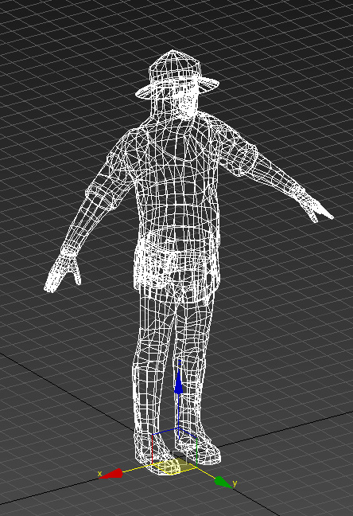

Transform/Scale Reset

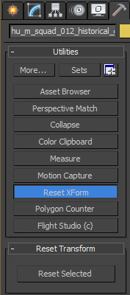
Use Reset xForm to make sure the character is aligned correctly.

Biped

Activate figure mode.

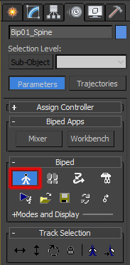

Skinning

Use the skin modificator on the figure. Add the bones. Make sure that all bones of the biped are covered. Do not add the nodes of the biped though.
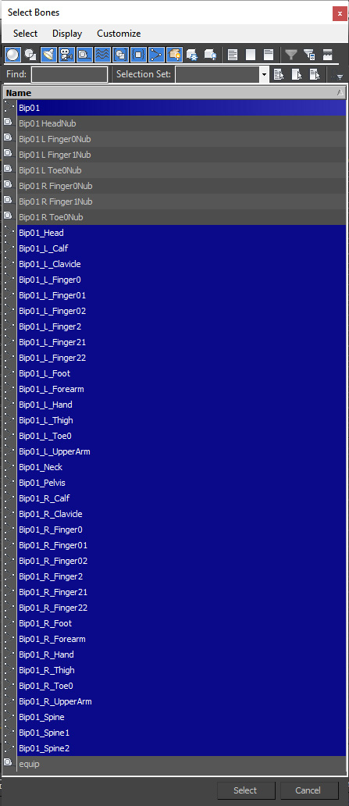
Every bone must affect at least one vertex or it will not be contained in the export later.

Set Bone Affect Limit to 4.

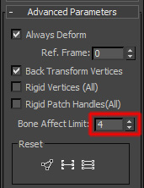

Skinning The LODs

To save some work use the skin wrap modificator on the LODs and use the detailed mesh as reference.

Make sure to have it set up like this:
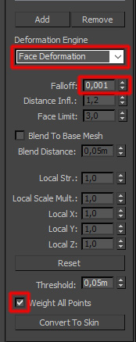
Now click „Convert to skin“ and set „Bone Affect Limit“ to 4.

Mesh Export

In the OgreMax Object Settings activate „Remove Bones With No Influence„ and „Export Animations to Seperate Skeleton Files“. Do this for LODs as well.

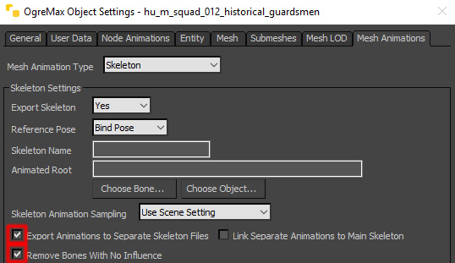
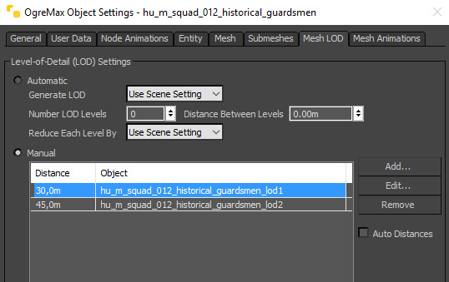
For LODs set the following:

Now select the figure and use „OgreMax->Export->Export Selected Object“ to export. The exporter should automatically find and add all LODs and bones.
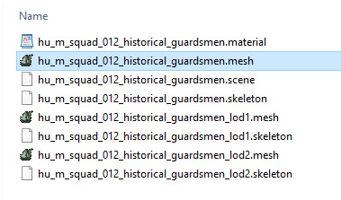
The exported files should look like this.

To import to EMERGENCY editor, simply drag and drop the main mesh file into the editor window (in this example „hu_m_squad_012_historical_guardsmen.mesh“). The editor should automatically find and add the other files.

Animation Export

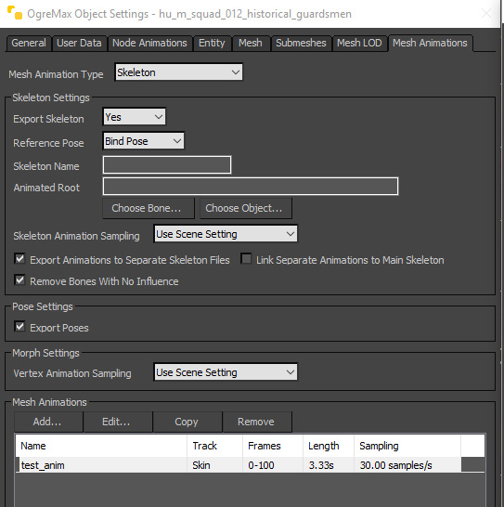
In the figure’s object settings add a mesh animation.

Set the animation’s start and end frames. Put in a name. Set sampling to 30 to make the animation smooth.
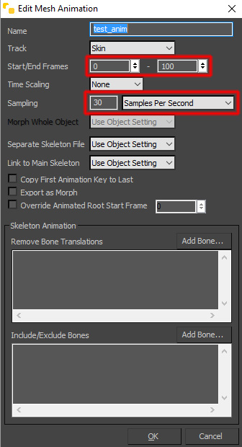
Now you can export the figure. The exporter will create a separate file. Drag and drop it into the EMERGENCY editor.

